**working on Bash-Scripting assignment-02.**

1) Create a bash script to **check if a directory is available or not**.

Script - #!/bin/bas

# Bash script to check if a directory exists

# Ask the user to enter the directory path

read -p "Enter the directory path: " DIR

# Check if the directory exists

if [ -d "$DIR" ]; then

echo "Directory '$DIR' exists."

else

echo "Directory '$DIR' does not exist."

Fi

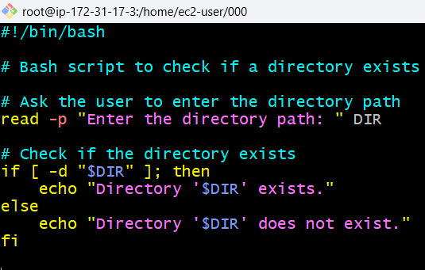

Output: 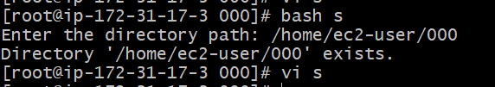

2)Create a bash script to **create multiple files**

SCRIPT - #!/bin/bash

# Bash script to create multiple files

read -p "Enter the names of files to create (separated by spaces): " files

for file in $files; do

if [ -e "$file" ]; then

echo "File '$file' already exists."

else

touch "$file"

echo "File '$file' created successfully."

fi

done

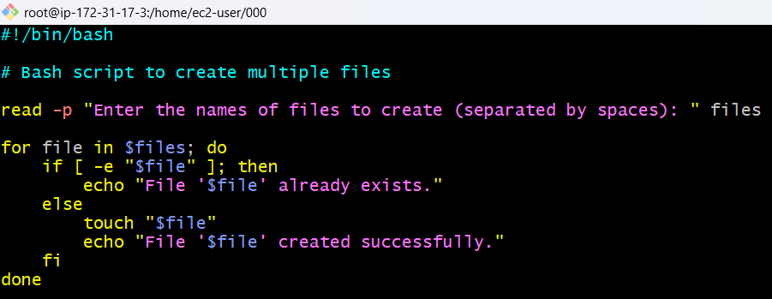

Output - 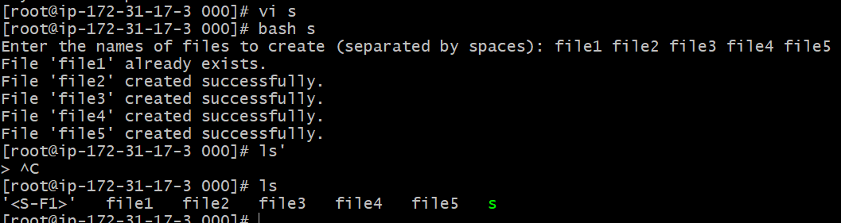

3) Create a bash script to **take a backup of a directory**

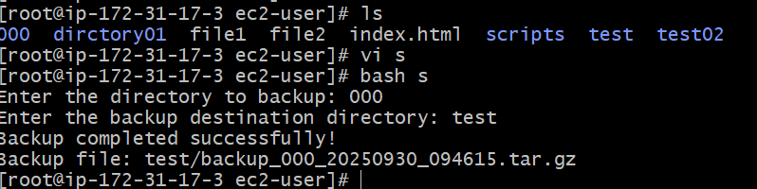

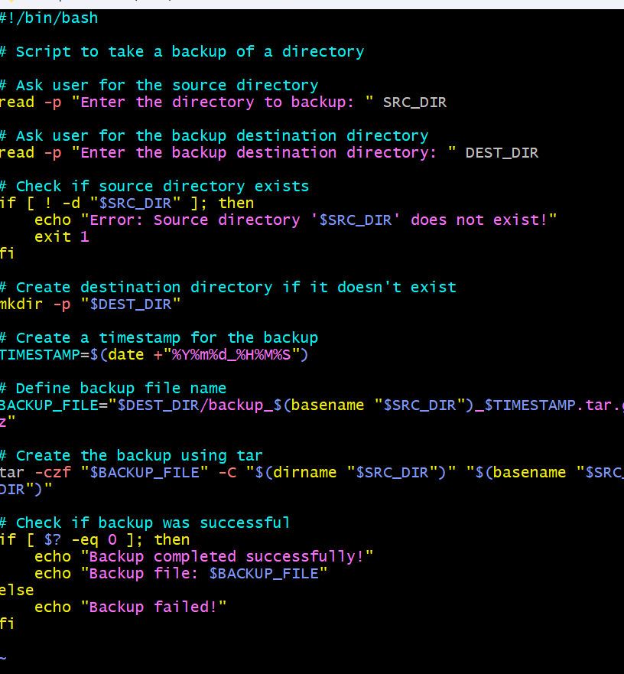

4) Create a bash script to **install Nginx on an EC2 server**.

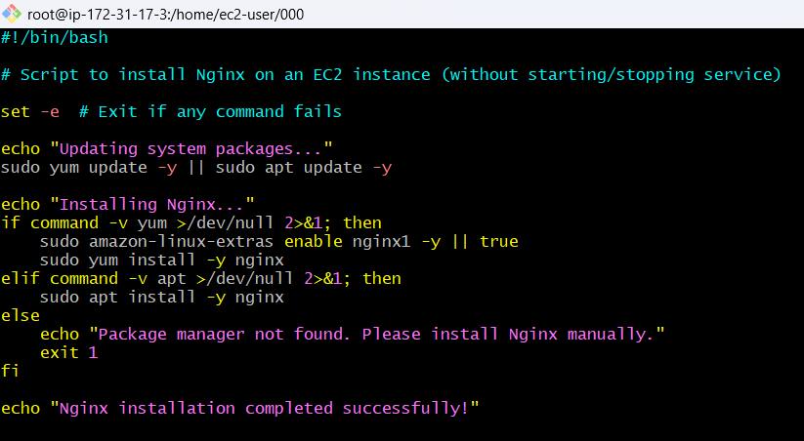

Output 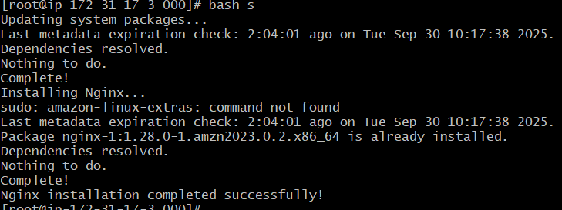

5) Create a bash script to **install Apache Tomcat on an EC2 server**.

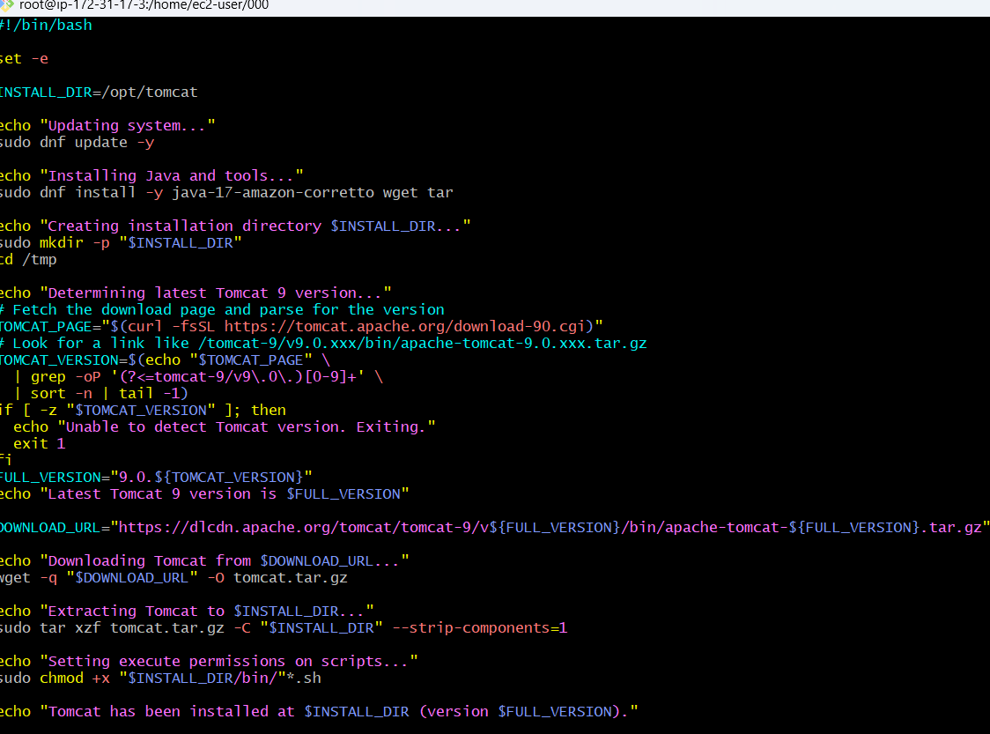

Output

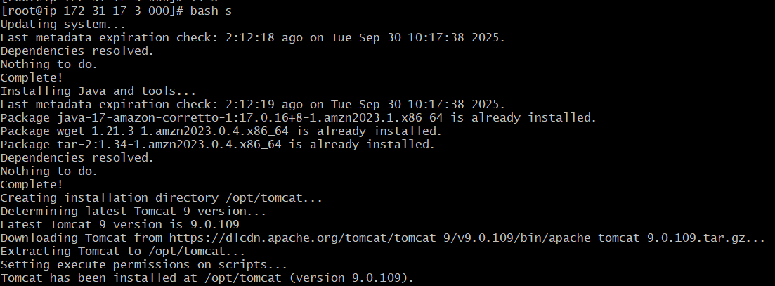

6) Create a bash script to **check if the Nginx service is running**, if not running then script should start the service

Script

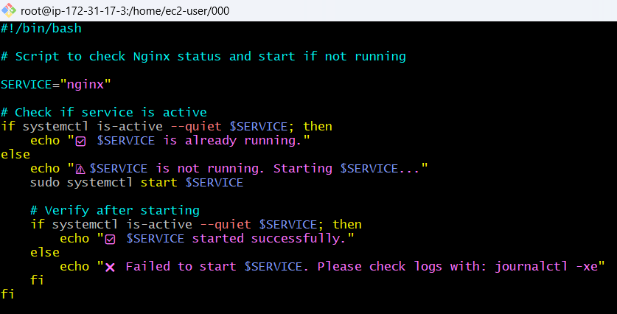

Output



7) write a script for calculator

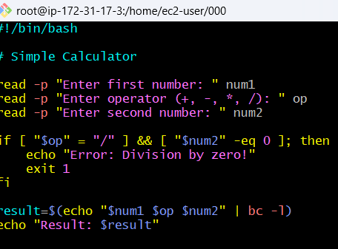

Output

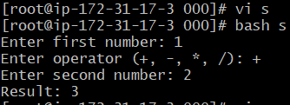

8) Create a bash script to **check if a directory exists**, if not then create a directory.

SCRIPT-

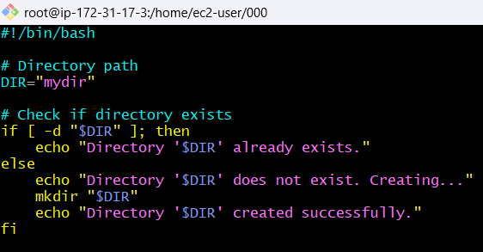

Output

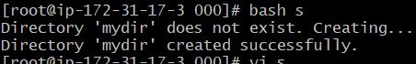

9) Create a bash script to **delete the last 3 lines of a file**.

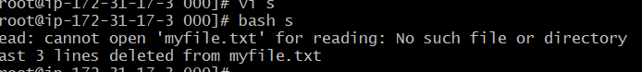\

10) Bash script to monitor cpu and if it is more than 80% then send email notification.

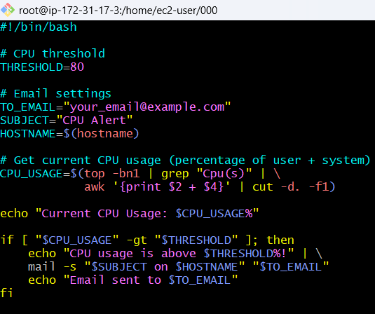

Output



11) Bash script to monitor disk space and if it is more than 80% then send email notification.

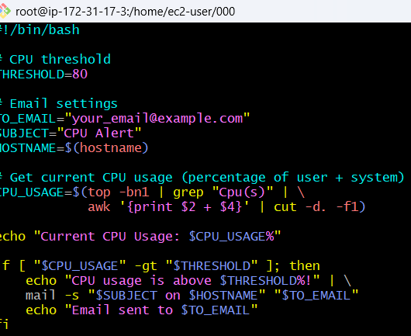

Output



12) Bash script to monitor memory and if it is more than 80% then send email notification.

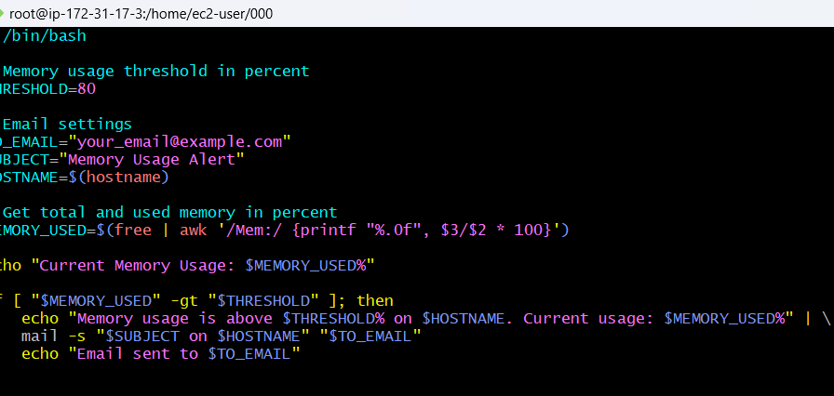

Output



**Exercise: Crontab Entries**

1. **April 5th Midnight**

0 0 4 5 *

1. 5th of Every November, January, June **if it is a Thursday**

* * 5 1,6,11 4

3. At **05 and 27th minutes** of **9, 10, 11** hours every day

1. 27 9 10 11 * * *

4 **34 minutes** of **9th hour** on **15th August**

34 9 15 8 *

5 Every midnight

1. 0 * * *

6 Every Weekend (**Saturday night 11:59 PM**)

59 23 * * 6

7 after every reboot

@reboot